EXPERIMENT – 6
PARSEVAL'S RELATION AND HARMONIC SPECTRUM ANALYSIS
OBJECTIVE
(i)To verify Parseval’s relation for continuous-time periodic signals and analyze the relationship between time-domain and frequency-domain power.

(ii) To analyze the distribution of signal power among the fundamental and harmonic components of periodic signals.

(iii) To determine and analyze the harmonic spectrum of continuous-time periodic signals.
(iv) To compare the total power obtained in the time domain with the harmonic power distribution in the frequency domain.

- To verify Parseval’s relation for continuous-time periodic signals and analyze the relationship between time-domain and frequency-domain power
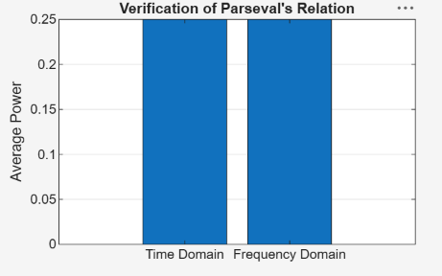

- To analyze the distribution of signal power among the fundamental and harmonic components of periodic signals.

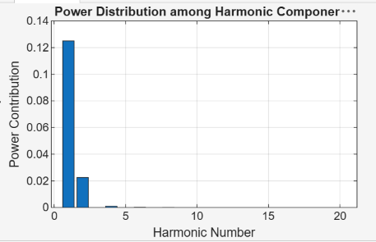

(iii) To determine and analyze the harmonic spectrum of continuous-time periodic signals.

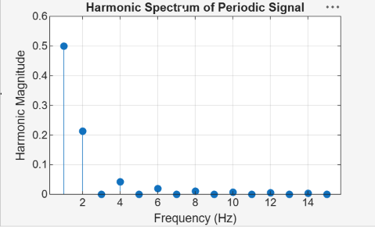

(iv) To compare the total power obtained in the time domain with the harmonic power distribution in the frequency domain

